**ISI – Inter Symbol Interference –**

Happens when communication system does not provide enough bandwidth. This will cause distortion of the signal.

2 Ways of dealing with Delay spread causing ISI on system level:  
1) Re-Design system to avoid it.  
2) Equalizer can do that using signal processing techniques   
  
Equalizer must balance ISI mitigation with noise enhancements because both passes thru equalizer.  
Wireless channel varies over time so equalizer must learn the response of the channel and then update itself as channel changes. This can be extremely challenging in a rapidly changing channel.   
  
Equalizer can be implemented at baseband, carrier RF or at an intermediate frequency. After ADC it is easiest to implement.

Linear equalizers that inverts filter of the channel including the noise can increase impact of the noise. Non-Linear equalizers handle that better.

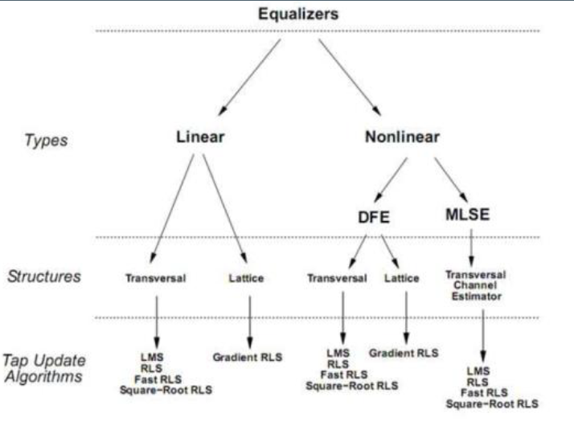

Types of equalizers:  
Normally 2 types: Linear and Non-Linear. Linear are simplest to implement and understand. They are not very used in advanced wireless communication.

In Non-Linear DFE (Decision Feedback Equalizer) is most common (not very complicated and performs well)

Optimal technique is to use MLSE (maximum likelihood sequence estimation) Problem is that complexity grows exponentially with length of the delay spread.

Linear and non-linear equalizers are typically implemented using Traversal or lattice structure.

Linear Equalizers:  
Zero-forcing:   
We are looking for inverse channel filter response for the channel response.  
We achieve solution by forcing the cross correlation between error sequence and the desired information to be zero. When this filter is applied we completely removed ISI. The drawback is that noise can be scientifically increased.

Minimum mean-square error (MMSE):  
With MMSE the goal is to minimize the average mean-square error between transmitted symbol and the symbol detected at the equalizer output.  
  
dk – output  
y[k] – input samples  
w – weights for MMSE

NON-LINEAR:  
MLSE (maximum likelihood sequence estimation):  
avoids the problem of noise since it does not use equalization filter

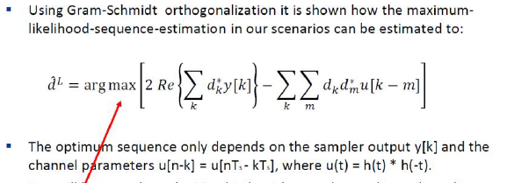

DFE:

